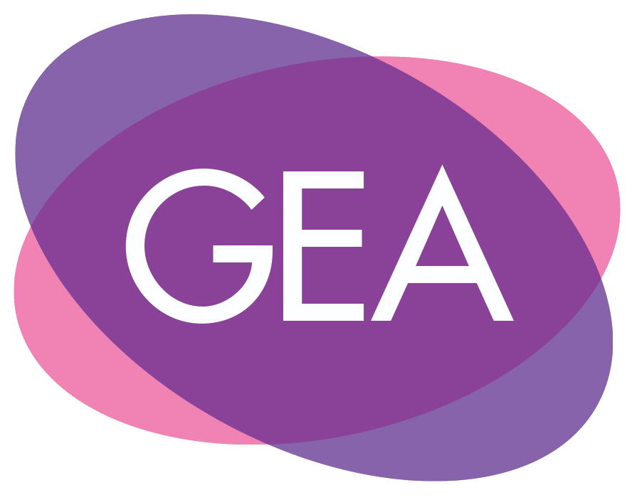

Application for membership to the Gender and Education Association Executive Committee

About You
Your Full Name
Your Organisation/ University/ School
E-mail
Social Media Profile (ex: Twitter or LinkedIn) (optional)

Which GEA Executive Role?
Please indicate which role this application is for:

Please tell us why you are applying for this role?
Please outline the reasons you would like to join the GEA Executive Committee. Tell us about the key skills and experience you have that will allow you to serve the Gender and Education Association in this specific role. (500-800 words maximum)

Equalities Monitoring information
Before submitting your application, please complete this Equality Monitoring Form:
https://forms.gle/QEYae5HBRcaTNaTn6
If you are applying for more than one Executive role, please only complete the Equality Monitoring Form once.
In order to better shape GEA's work as an international, intersectional feminist charity; to evaluate our activities, initiatives, and events; and to better understand and serve our members, we are asking questions related to: country of current residence, race/ethnicity, gender identity, disability, sexual identity, and pronouns. Categories have been drawn from standardised sources (such as HESA, Stonewall, and census questions) that do not fully reflect the diversity of possible responses to each question. Please feel free to self-describe where the available categories do not fit with your identities. Should you wish not to disclose this information, please select ‘prefer not to say’.

It is the policy of GEA to provide equal opportunities without regard to race, religion, national origin, gender, sexual preference, age, or disability.

Agreement and Signature
By submitting this application, I confirm that the facts set forth in it are true and complete. I understand that if I am accepted onto the GEA Executive Committee, any false statements, omissions, or other misrepresentations made by me on this application may result in my immediate dismissal.
Name (printed)
Signature (printed if you do not have a digital signature to add)
Date

About GEA
The Gender and Education Association is a volunteer-led international intersectional feminist charity. Since 1997, our community of educators, researchers, activists, leaders, artists, and more have been working to challenge and eradicate gender stereotyping, sexism, and gender inequality within and through education. UK charity number: 1159145

Please apply by completing the Equality Monitoring Form and sending a completed application and your CV to: GenderAndEd@gmail.com
Thank you for completing this application form and for your interest in GEA.

